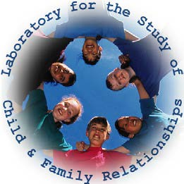
Laboratory for the Study of Child and Family Relationships

Director: Dr. Kenneth H. Rubin

Independent Research/Internship Experience: Application Form
Dept. of Human Development & Quantitative Methodology University of Maryland 3304 Benjamin Building College Park, MD 20742

Contact Info
Name: | UID # (for registration purposes):
Email: | Phone:
What is the best way to contact you? (e.g., via cell phone)
Academic History
Class Standing: | GPA: | Major(s):
Have you ever withdrawn from a class? | Have you ever received a C or below for a class grade?  NO YES
If “yes” course name:  Explain reason for withdrawing: | If “yes” course name:  Explain reason for low grade:
Research Experience:
What are your professional goals?
Describe your experience with children:
Describe your research in other lab or research settings:

How many credit hours (EDHD 498) do you wish to take?
Though not a requirement for participation in our lab, do you have a car or will you have regular access to a car this term? YES NO
Once the term begins, lab meetings will be held every Friday from 10:30am – 12:00pm. Please confirm that you will be able to attend these meetings: YES NO

Submission Instructions:
Please complete this form and email it to Dr. Kenneth Rubin at krubin@umd.edu. If you cannot complete this form and save it as a PDF please fill in the fields and either print and scan it or mail it to:

Kenneth H. Rubin, Ph.D. 3304 Benjamin Building College Park, MD 20742

